In the final dialog with Dr Johnson set a flag that will trigger:

1. Military bot EnterWorld in Docks;
2. All of the ships destroyed (with debris CNN.AiMetalFragment)

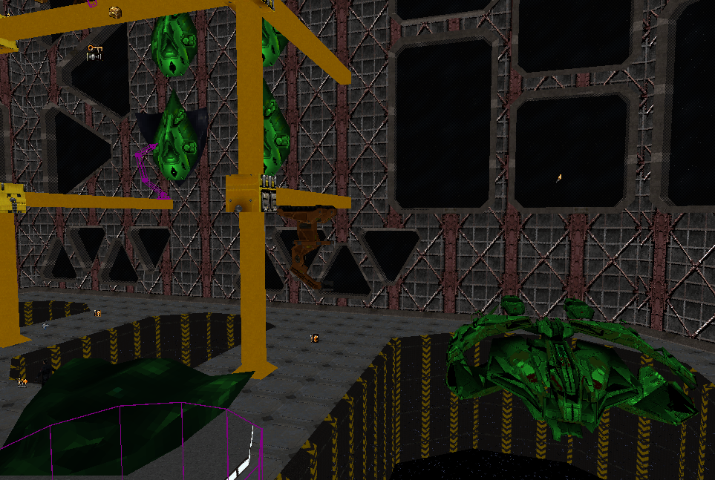

# Goals

The player will find a flamethrower and a GEP gun with WP rockets.

1. Destroy the body of Paul Denton : flammable carcass

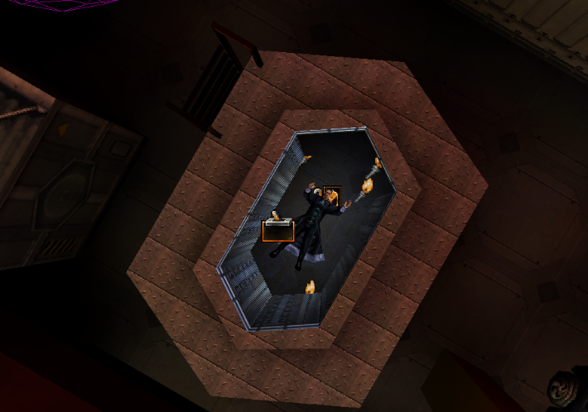

1. Destroy President Mead’s dummy avatar: flammable carcass, debris type CNN.AiMetalFragment

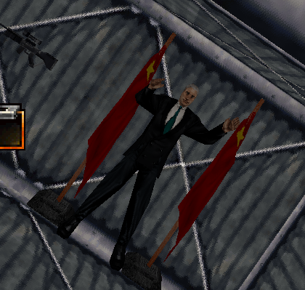

1. Destroy Nazi Buddha: make the Buddha flammable

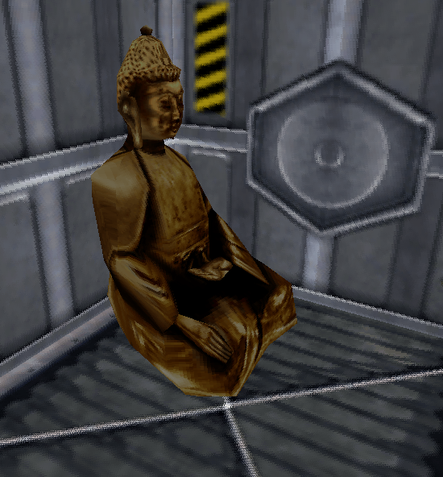

1. Destroy bones of the Desposyni: make bones and skulls flammable like wooden crates

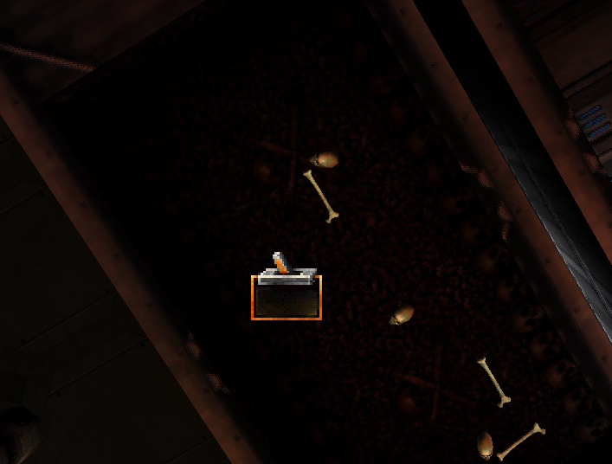

1. Destroy the Dentons’ car wreck: the car is NOT flammable

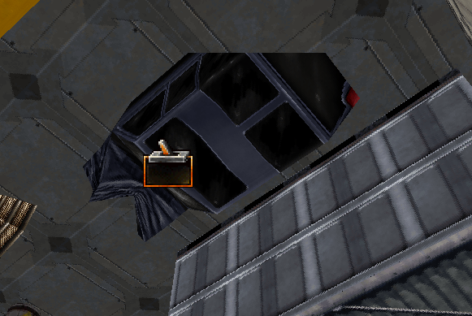

1. Destroy the head of the Statue of Liberty: OT flammable but destructible. Need to make a new class because StatueOfLibertyHead cannot be set to destructible.

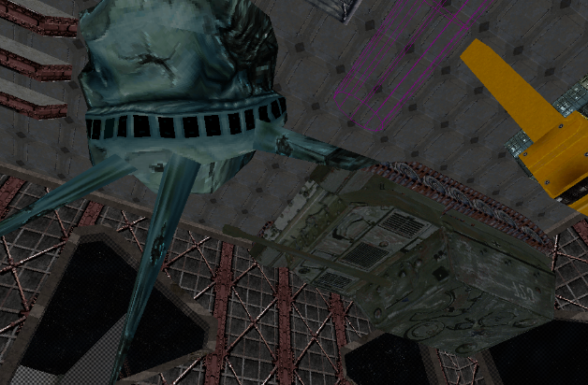

1. Destroy the Ratte Tank: NOT flammable
2. Destroy Grey Death barrels: Flammable, like wooden crates

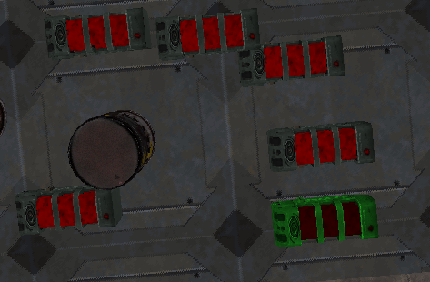

1. Destroy the Mona Lisa: Flammable, make it a mover

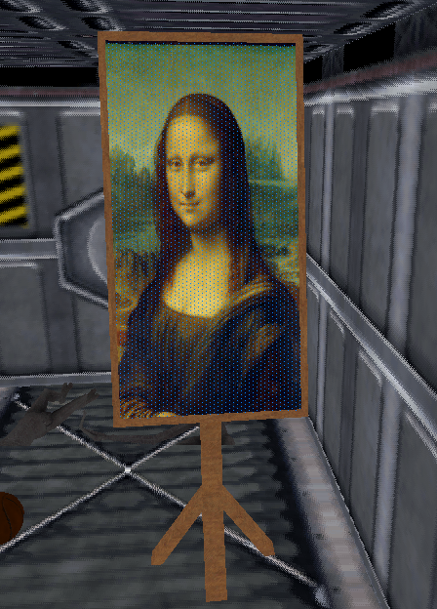

1. Destroy the Grays’ bodies: flammable carcass

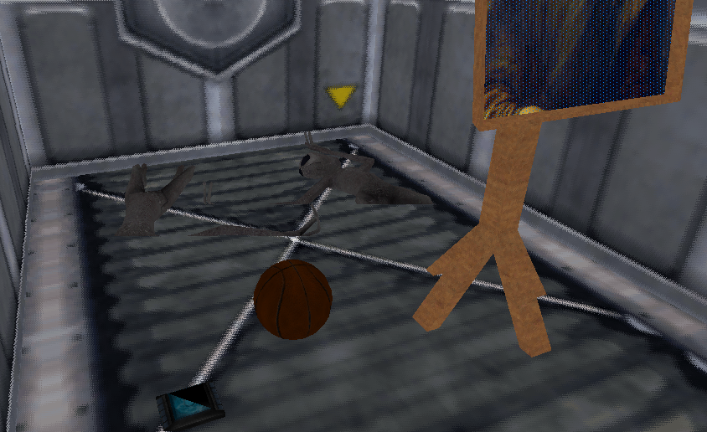

1. Destroy the Jet Engine: mover, flammable

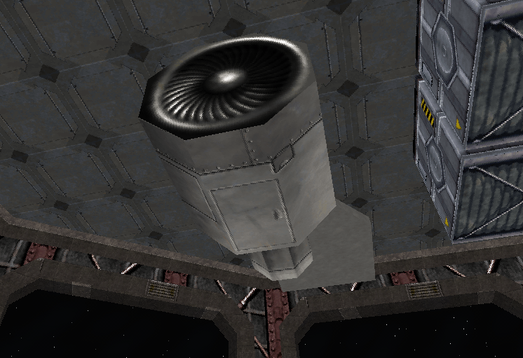

1. Destroy the shells of American and Soviet nukes: movers, NOT flammable

